Biological signal analysis final project - Mole-rat seismic communication  
Tami Yosef and Carmi Yeffet

Mole rats use head drumming to communicate. In this project, we sought to answer two questions. First, do individuals possess unique drumming signatures?  
Second, given a drumming recording, is it possible to determine which individual was addressed?

Head drumming communications were collected from a colony of tagged individuals, and the sound files were later annotated with the individual making the noise and the one receiving it. Therefore, this makes for a dataset of 2134 recoding at the length of ~0.05 seconds and a sampling rate of 44100Hz. As a first step, all the waveforms were smoothed using a Gaussian filter to reduce the number of peaks in the waveform. This step is crucial since our analysis assumes the most prominent peak in a recording encodes useful information for making predictions. The most prominent peak was determined to be the loudest peak out of the collection returned from the find peaks function in Scipy.   
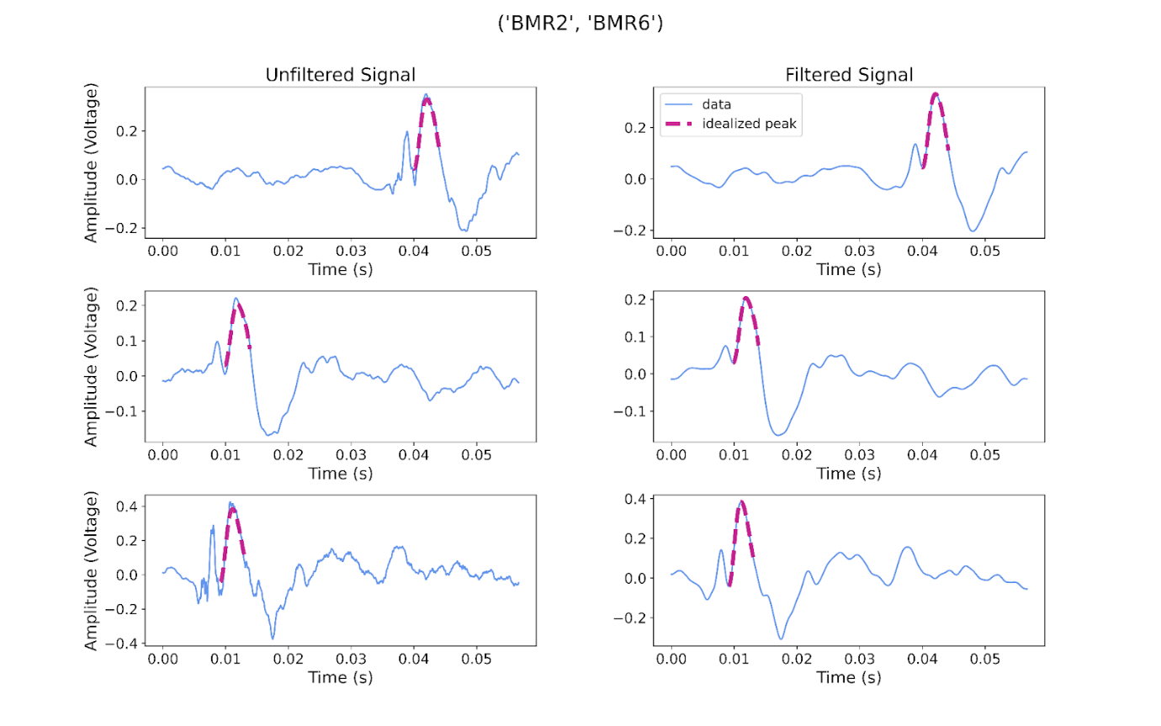

Fig 1. Head drumming waveform made by individual 2 and directed at individual 6. On the left, the raw waveform as recorded from the microphone. On the right, the signal after Gaussian preprocessing and peak detection. The identified peak is marked with a red dashed line.

With the peaks in hand, we proceeded to group all the individual drummer recordings, that is, all the recordings were a certain individual drummed irrespective of whom they were addressing. The same applies to all the communications an individual received. Making for a dictionary holding all data in an easy-to-access format. Example:   
{

'by_maker':

{

'grouped_data': {...},

'filtered_data': {

‘BMR3’: [ All recordings data smooted],

‘BMR4’ : [ All recordings data smooted]...

},

'grouped_peaks': {...},

'grouped_intervals': {...}, …

},

'by_receiver': {same as maker}

}

Code snippet 1. The main data container in the program. Indexed by all the recordings that belong to either a specific noise maker or a noise receiver. ‘grouped_data’ holds the raw data from all WAV files for an individual. 'filtered_data' is the data post-Gaussian smoothing. 'grouped_peaks', are peak values. 'grouped_intervals' is a list of the peak indexes as they appear in the filtered data and the grouped data lists.

We then proceeded to establish what should be the ideal peak width for each individual (both noise maker and receiver). The mean length of the peaks for each individual was calculated and saved, this will be the length of the idealized peak for that individual under the given interaction (noisemaker or the listener). All peaks shorter than the desired length were padded symmetrically with zeros and all peaks longer than the desired length were trimmed equally from both sides. The mean of the peaks at the uniform length was calculated making for the idealized peak for an individual in the specific role. Each idealized peak was convolved with about 80% of the original data that was used to build it and the distribution was plotted.

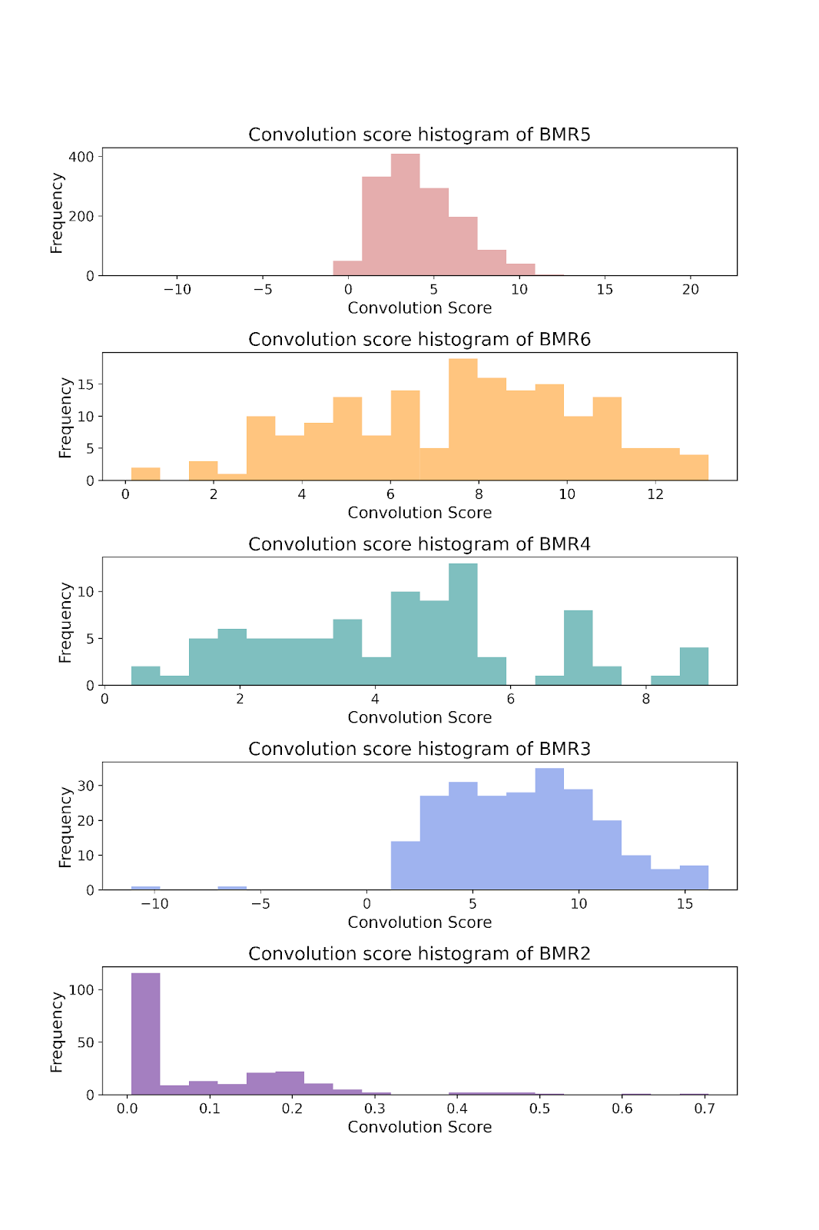

Fig 2. The distribution of convolution scores between all peaks from a listener and its idealized peak.  
  
These distributions are used for the classification of a recording. Given a test recording, peak identification will be done as described above and the found peak will be convolved with all idealized peaks. Provided the convolution score, the test peak’s percentile in each distribution is examined, and the distribution where the peak got the highest score will be the prediction made for it.

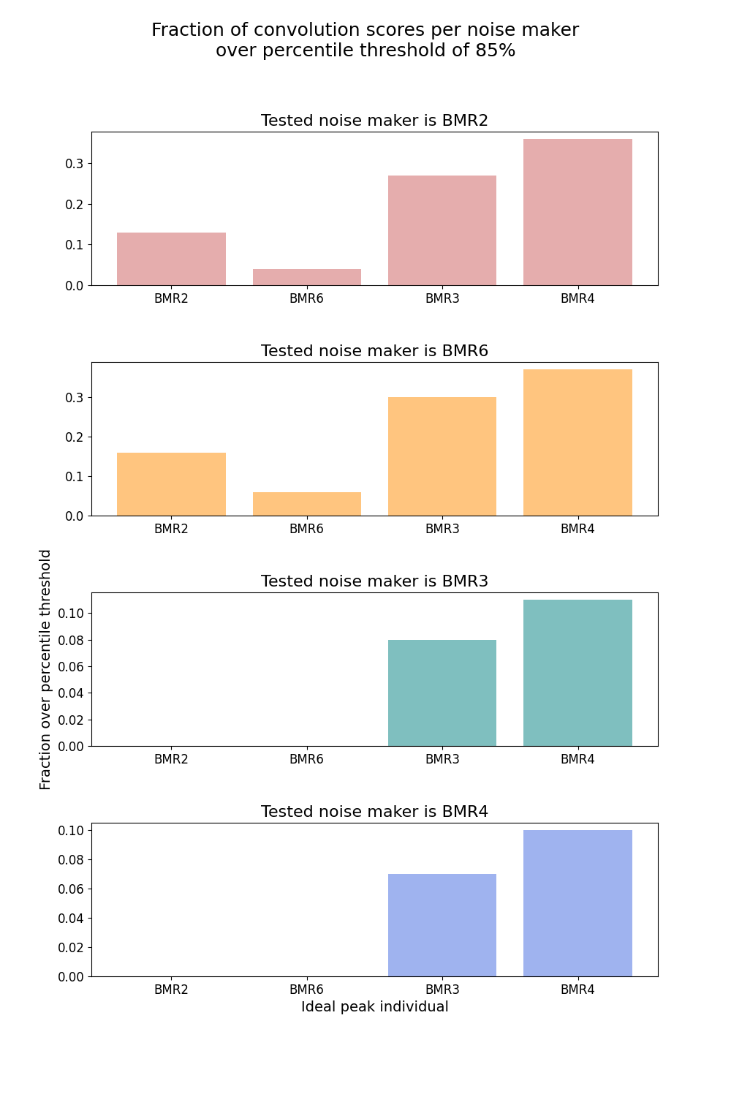

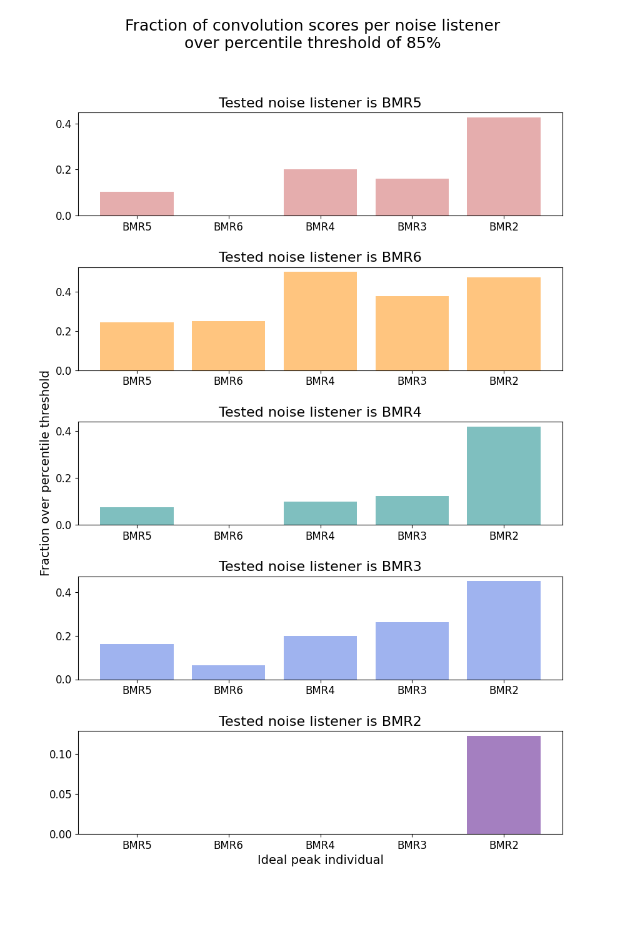

Fig 3. Prediction results, the heading of each plot notes the ground truth, and the bar with the highest number is the prediction.

Unfortunately, our analysis didn’t yield high predictive power (most of the above did not match the highest bar with the ground truth) so both questions remain open. A potential avenue to giving a more decisive answer would have been some form of deep learning. We had tried to implement such a solution but lacked the needed background, therefore, we stuck with methods of which we had a good understanding and that might have led to interesting biological findings. Mainly, if the loudest peak in the waveform does, in fact, code for most of the communication. As mentioned, this remains unclear with our analysis as the sole source of evidence.